Quality Tips for Video Game Streaming and Recording

Live Streaming

Platform should contain minimal javascript
Platform should have adjustable resolution for videos
Platform should rank the videos by current viewers
Platform should not mix prerecorded and live playthroughs
The dominant format for playthroughs should be the Let’s Play format (see https://en.wikipedia.org/wiki/Let%27s_Play). The player should be on the right of the screen, or left if he/she overlays a game widget by being on the right.
The player should use a blue or green-screen to subtract the background when it is overlayed upon the video game.
There should be no watermarks or additional advertising.
There should be no paywalls or logins to watch and no DRM.

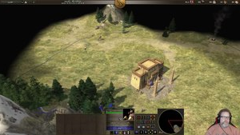

Recordings

There should be no watermarks or advertising.
There should be no paywalls or logins to watch and no DRM.
The game should be played all the way through, and completed.
Do not dilly dally in the game, but do not ‘speed run’.
Unlike live streaming, there should be no commentary in the video.
Watch the cut-scenes and the introduction/ending.
If the game has more than one ending, aim for the best ending possible.
If the game has alternate realities. Go back and complete the missions and add them to the end of the video. Label it as an alternate reality.
If the music is repetitive and annoying throughout the whole of the game, play the complete tune once, then turn it off.
Leave sound effects on.
Do not add your own additional introduction clip/ending clip.
If you need to take breaks, you should make it so the video is seamlessly edited as if you didn’t take a break.
It should be one long video, rather than lots of separate videos.
Try and capture the essence of the game - you are creating a production video.

